**PEMOGRAMAN II**

**“LAPORAN PRAKTIKUM 2”**



**PRAKTIKAN**

**NAMA : VIRGIE SCIORRA**

**NPM : 4511210014**

**JURUSAN TEKNIK INFORMATIKA**

**FAKULTAS TEKNIK UNIVERSITAS PANCASILA**

**JAKARTA**

**2013**

**PERTEMUAN II**

APP.JAVA

package belajar.autotes;

public class App

{

public static void main( String[] args )

{

System.out.println( "Hello World!" );

System.out.println( "hallo belajar run!" );

}

}

Apptest.java

Source code

package belajar.autotes;

import junit.framework.Test;

import junit.framework.TestCase;

import junit.framework.TestSuite;

/**

* Unit test for simple App.

*/

public class AppTest

extends TestCase

{

/**

* Create the test case

*

* @param testName name of the test case

*/

public AppTest( String testName )

{

super( testName );

}

/**

* @return the suite of tests being tested

*/

public static Test suite()

{

return new TestSuite( AppTest.class );

}

/**

* Rigourous Test :-)

*/

public void testApp()

{

assertTrue( true );

}

}

Hello test.java

Source code

package belajar.autotes;

import junit.framework.Test;

import junit.framework.TestCase;

import junit.framework.TestSuite;

/**

* Unit test for simple App.

*/

public class AppTest

extends TestCase

{

/**

* Create the test case

*

* @param testName name of the test case

*/

public AppTest( String testName )

{

super( testName );

}

/**

* @return the suite of tests being tested

*/

public static Test suite()

{

return new TestSuite( AppTest.class );

}

/**

* Rigourous Test :-)

*/

public void testApp()

{

assertTrue( true );

}

}

PRINT SCREEN

mvn archetype:create -DgroupId=belajar.autotes -DartifactId=belajar-autotes

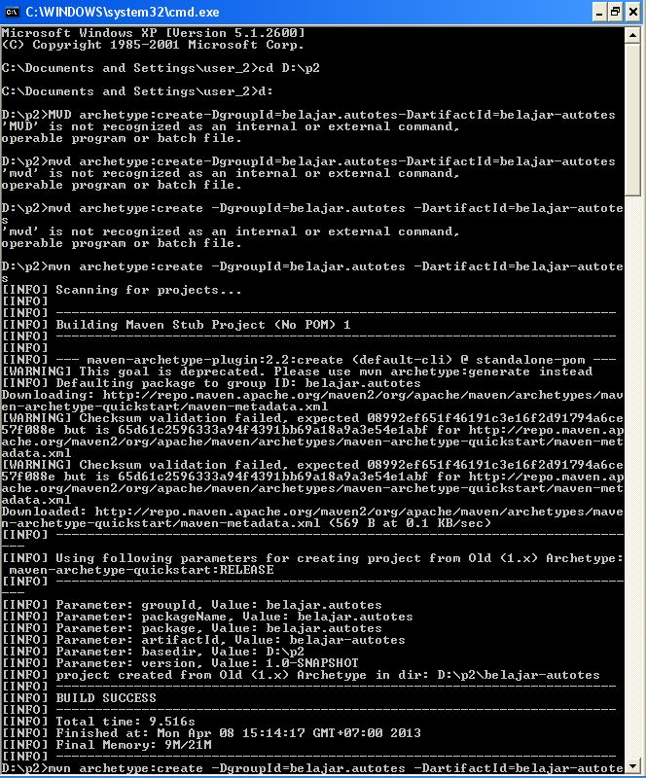

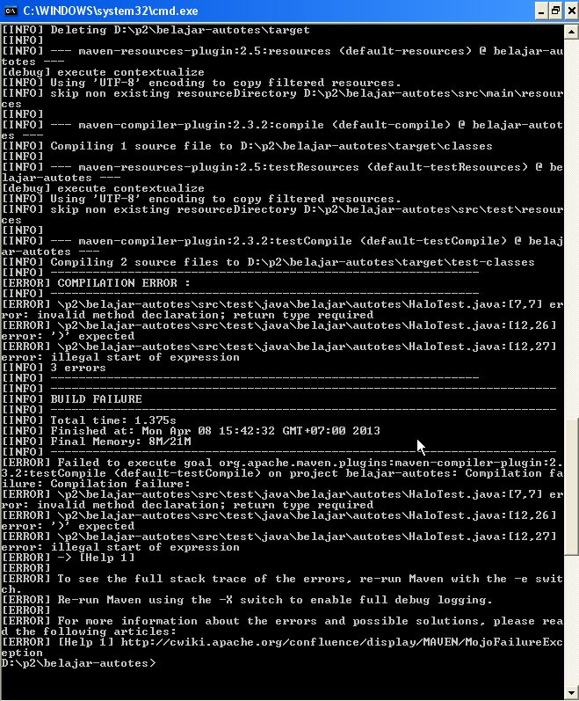

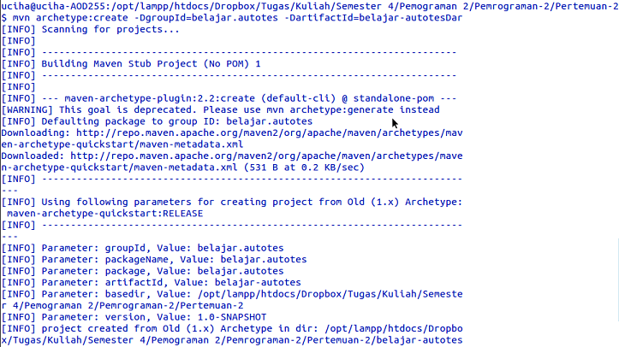

mvn clean package

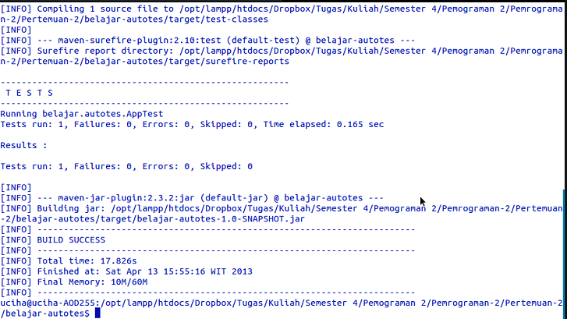

mvn exec:java -Dexec.mainClass=belajar.autotes.App

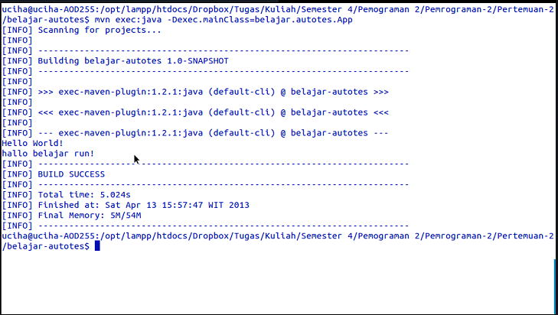

mvn clean package

